EXPERIMENT 2
Image Resizing and Scaling using OpenCV
SOURCE CODE :
import cv2
img = cv2.imread(r"C:\Users\Amrita\Desktop\image\input_image.png")
# Resize image to width=250 and height=200
resized = cv2.resize(img, (250, 200), interpolation=cv2.INTER_AREA)
cv2.imshow("Original Image", img)
cv2.imshow("Resized Image", resized)
cv2.waitKey(0)
cv2.destroyAllWindows()
Output
Original image
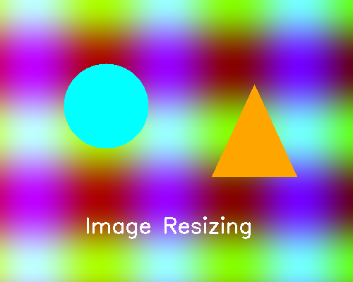
Resized image
